RS211C/419C, RS228/419C, RS249/419C

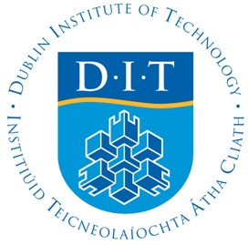

DUBLIN INSTITUTE OF TECHNOLOGY
_____________

DT211C BSc. (Honours) Degree in Computer Science (Infrastructure)

Year 4

DT228 BSc. (Honours) Degree in Computer Science

Year 4

DT249 BSc. (Honours) Degree in Information Systems / Information Technology

Stage 4
______________

SUPPLEMENTAL EXAMINATIONS 2016/2017
______________

Artificial Intelligence II [CMPU4011]

Mr. Giancarlo Salton
Dr. Deirdre Lillis
Mr. Tom Nolan – DT211
Mr. Paul Collins – DT228
Dr. Rem Collier – DT249

Date & Time TBA.

Two Hours

Instructions to Candidates

Question 1 is compulsory.

Answer Question 1 (40 marks) and

any 2 Other Questions (30 marks each).

